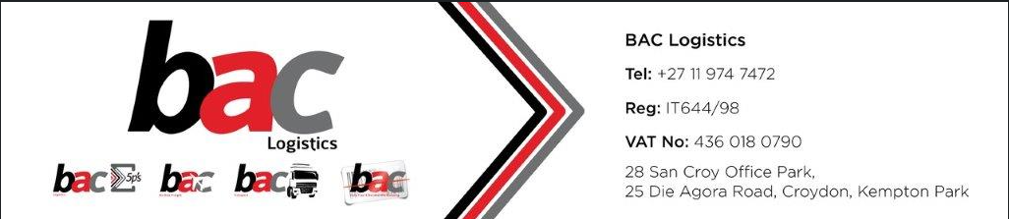

Master Instructions
AIRFREIGHT
Please consign all MAWB as below and mention goods description as ‘consol’ and email full pre-alert to teamairandsea@baclogistics.co.za
BAC Logistics
28 San Croy Office park
25 Die Agora Road
Croydon
South Africa
1619
Tel: +27 10 974 7472
teamairandsea@baclogistics.co.za
Documents required:
- Copy of MAWB
- Copy of HAWB
- Copy of Commercial Invoice and Packing List

SEA FREIGHT
Please consign all MBLS as below and email full pre-alert to teamairandsea@baclogistics.co.za
BAC Logistics
28 San Croy Office park
25 Die Agora Road
Croydon
South Africa
1619
Tel: +27 10 974 7472
teamairandsea@baclogistics.co.za

